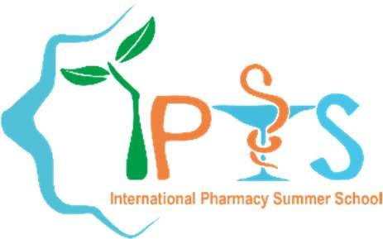INTERNATIONAL PHARMACY SUMMER SCHOOL

SIZED RECENT PHOTOGRAPH

Association of Pharmacy Student Department of Pharmacy

Faculty of Medicine and Health Sciences Universitas Muhammadiyah Yogyakarta Yogyakarta - Indonesia

Email: [ipss@umy.ac.id](mailto:ipss@umy.ac.id) Website: https://ipss.umy.ac.id/

STUDENT APPLICATION FORM IPSS 2021

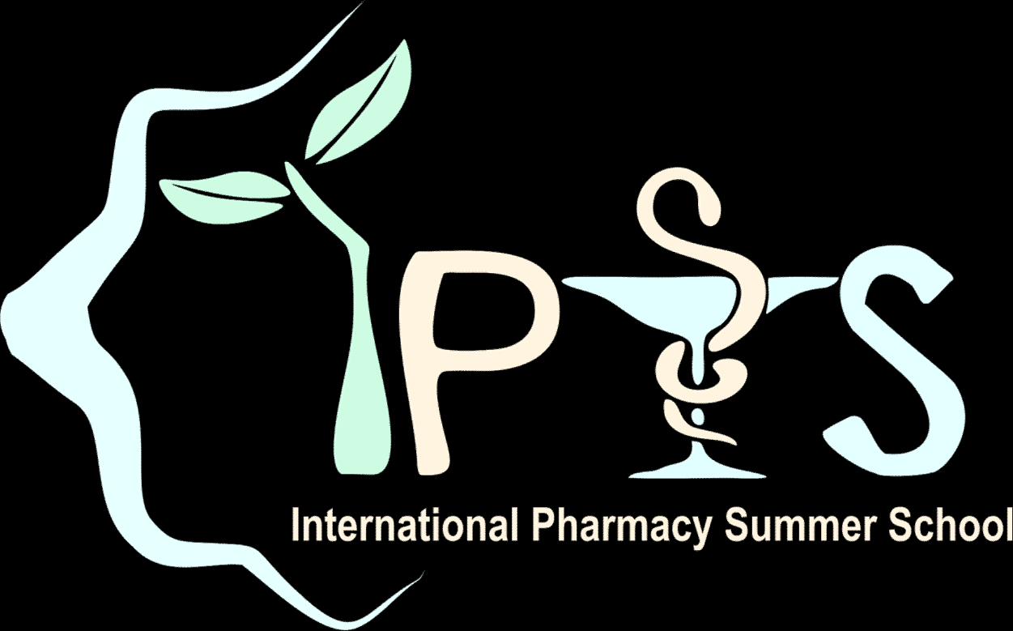This year IPSS will be held on 14th July 2021 – 20th July 2021. Please fill the form below completely.

PERSONAL DETAILS

Full Name : _ _

Instant Messenger ID:

_ Preferred Method of Contact :

Nick Name :

Gender : [ ] Male [ ] Female

Birthday : Nationality : _ _ Address : _

_

_

[ ] Phone [ ] Email

University :

_

_ School Attended : [ ] Pharmacy

Level : [ ] Student*

[ ] Graduate

_ *Year Level in 2021 : _ Home Number : _

Mobile Number: _ Email Address :

Native Language/s : Second Language/s :

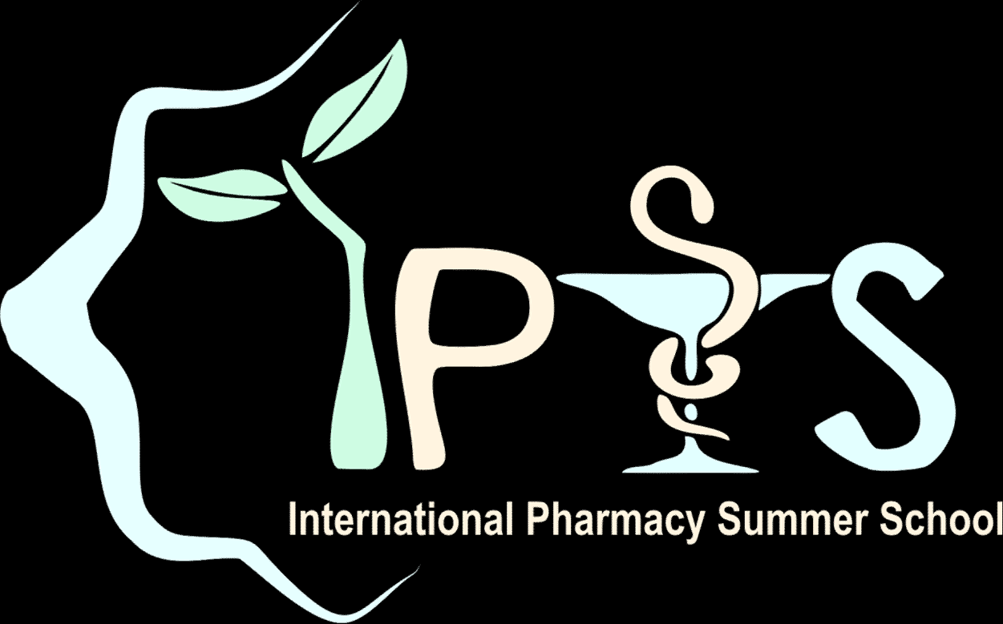

SUMMER SCHOOL EXPERIENCE

is there any pharmacy summer school you have attended before? [ ] Yes – Please specify [ ] No

|  |  |  |  |
| --- | --- | --- | --- |
| Name | Topic | Year | City & Country |
|  |  |  |  |
|  |  |  |  |
|  |  |  |  |
|  |  |  |  |
|  |  |  |  |

IPSS 2021 SURVEY

How do you rate your knowledge in the field of Indonesian indigenous medicine in modern medical treatment?

[ ] None, but I’m eager to know [ ] Beginner* [ ] Experienced in this field*

*If you check one of the boxes with this (*) sign, please state briefly why you rate yourself in that level.

How did you hear about IPSS 2021? (You can sign more than one checkbox) [ ] Friend/previous IPSS participant

[ ] Email

[ ] Mailing list, please specify

[ ] Faculty

[ ] Poster

[ ] Leaflet

[ ] Website (including Google search)

[ ] Publication in Pharmacy Conference

[ ] Others, please specify

MOTIVATION AND EXPECTED OUTCOMES

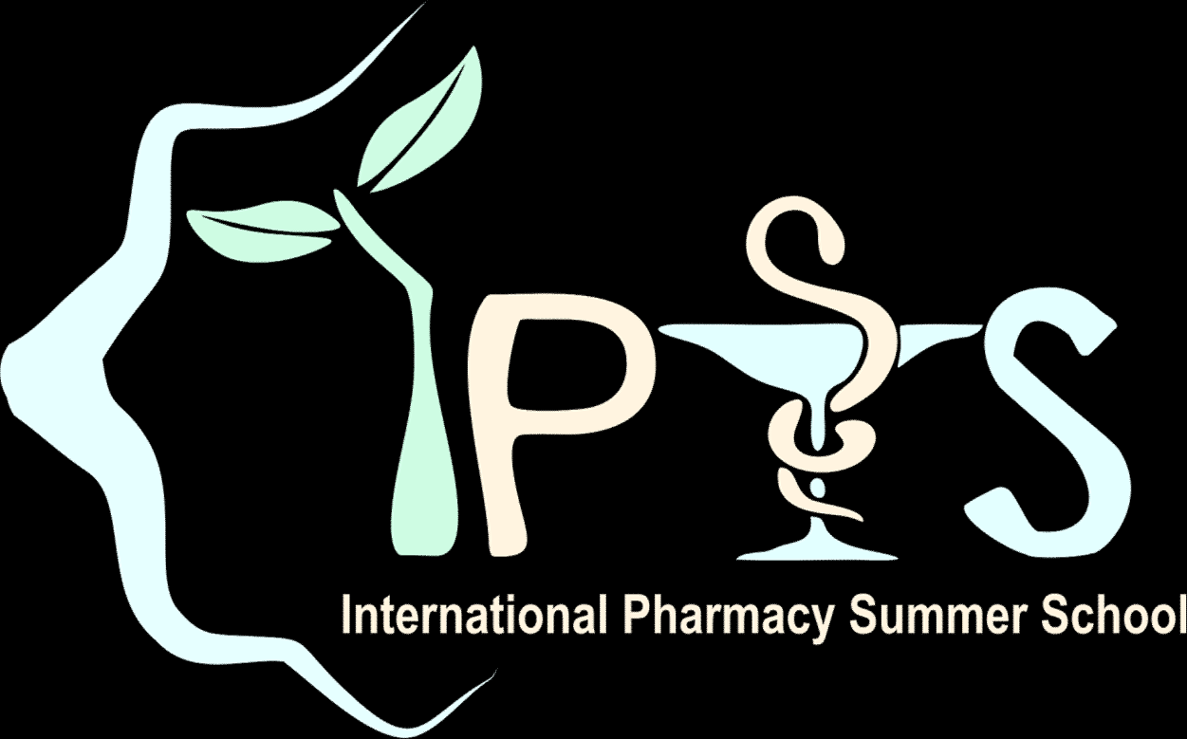Motivation letter:

We are very pleased if you could state briefly your expected outcomes by joining IPSS 2021.

PAYMENT

* + 1. Cost:
       - This payment **includes**: All of agenda in this event
       - This payment **does not include**: Banking transfer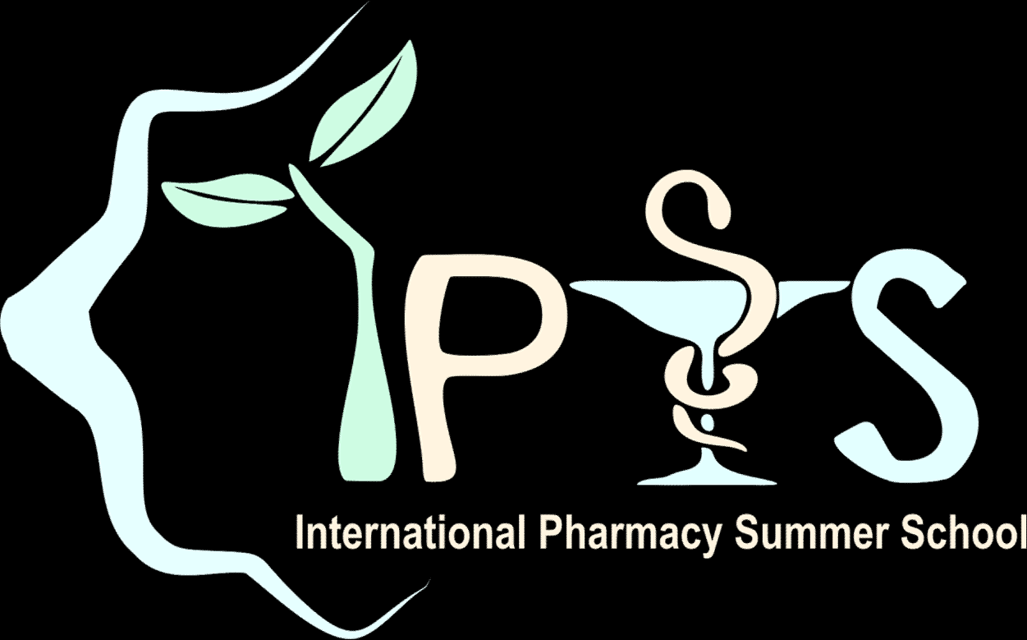

# Payments that have been made are not refundable

* + 1. Before the IPSS 2021 starts, change/s to this “terms and conditions” are possible to be made by the Organizing Committee without any permission from the participants.
    2. If there any changes have been decided, the Liaison Officer will inform participants immediately.

METHOD OF PAYMENT

Bank Transfer

We will start the payment period on:

* First batch : 10th May – 6th June 2021
* Last batch : 7th June – 30th June 2021

**The payment period starts** after you received Letter of Acceptance as Participant of IPSS 2021. **The Payment deadline** is 10 days after you get Letter of Acceptance & send the scanned proof of payment plus 5 days to remind you if you have not paid & send the proof of payment in 10 days.

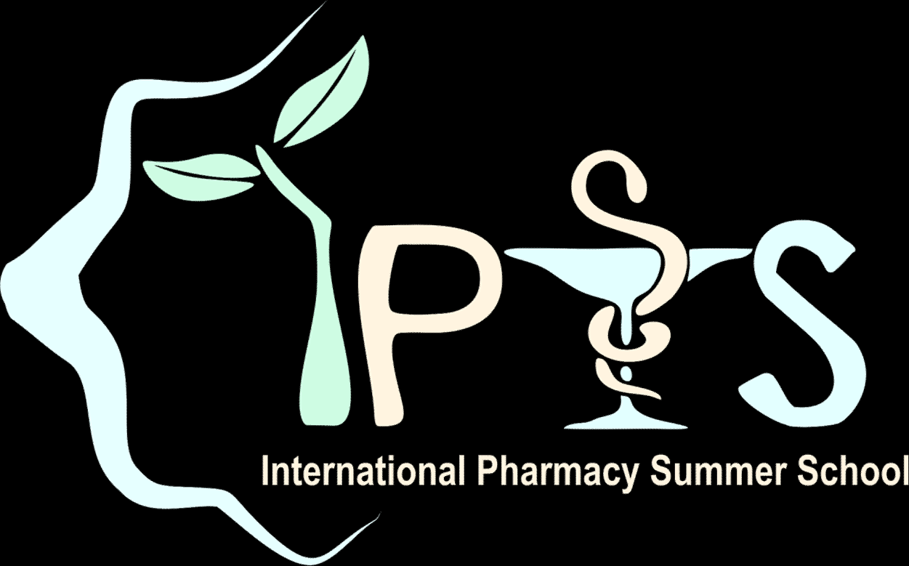**The official bank account will be announced soon to the applicants via email**. If you have any problem with this method of payment, feel free to contact us.

(place), (date), 2021 (Signature Here)

# Please print this form after you fill in its entirety and sign it with written signature. Send a colour scanned document of this form to: [ipss@umy.ac.id,](mailto:ipss@umy.ac.id) and bring the original form when you join this program.